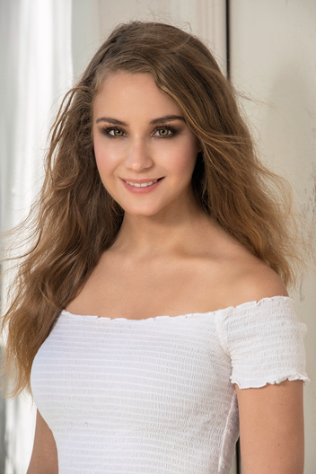
Michelle Ljungcrantz
Längd: 160 cm
Vikt : 45 kg
Hår: Mörk blond
Ögon: Gröna
Telefonnummer: +46-703563177
Email: michelle.ljungcrantz@hotmail.com
Address: Kobergsgränd 4, 58731 Linköping, Sweden
TEATER
Roll Plats
Violette Sharp Violette/Huvudroll David Hall Theatre
Appropriate. Cassady David Hall Theatre
Chekhov in Yalta Fyokla David Hall Theatre
Cesar Chaves Helen David Hall Theatre

FILM
Roll Direktor
Falling petals Samantha Kameron Bassari
Bora Linda Tiffany Toney
Actors vs Interruptions Amanda Sebastian Angborg

UTBILDNING

Michelle Danner acting studio (2019-2021)

Lärare
Audition for film and Audition Technique 1&2 Doug Kaback

Self-Taping Audition Technique 1&2 Doug Kaback

Improvisation workout 1&2 Derek Reed

Scene study 1&2 Michelle Danner
The joy of acting Micheal Nouri

Uta Hagen Julien Hening

Stella Adler Academy of Acting & Theatre (2016-2018)
Lucid Body Technique Kennedy Brown
On Camera Rick Peters
Improve to scene 1&2 Chee Walker
Scene study 1&2 Christopher Thornton
Scene study Advanced Tim MacNeil
Script Break Down Christopher Thornton
Shakespeare 1&2 Bruce Katzman
Chekov Bruce Katzman
Stella Adler Technique Laura Leyva
Stella Adler Technique 2 Tim MacNiel
Stella Adler Technique 3 Tracey Ellies
Alexander Technique 1&2 Celio Silveria
Character Tim MacNiel
Speech 1&2 Timothy Kopacz
Movement 1-6 Kennedy Brown

New York Film Academy Sydney (2013-2015)
Meisner Technique 1&2 Hunter Macmahon
Stage Combat 1&2 Hunter Macmahon
Audition technique Grant Thompson
Monologue technique Grant Thompson
Scene study 1-4 Jacqueline Marriot
Acting for film 1-4 Sebastian Angborn
Comedy 1&2 Guillaume Barrier
Shakespeare 1&2 Clara Voda
Chekov Bogdan Voda
Voice and Movement Jacqueline Marriot

UNIKA EGENSKAPER
Professionell skidåkare, kan rida hästar och kan prata flytande engelska.

